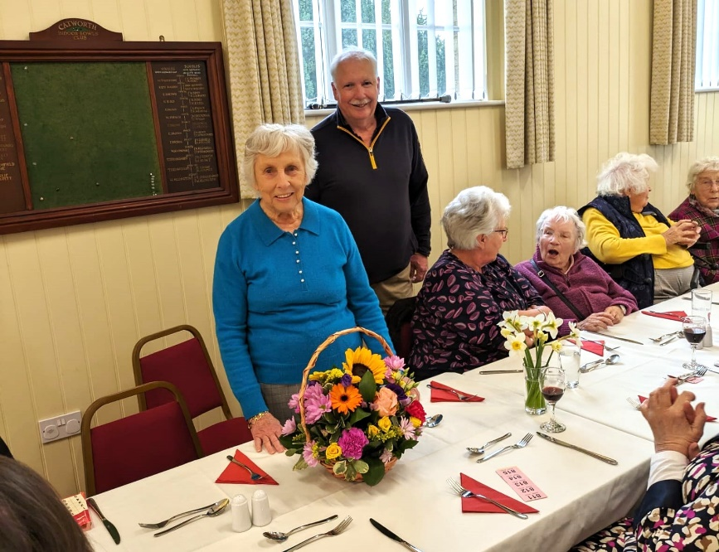
Village Hall lunch 2024
Vivien was one of the three who started the village lunch many years ago. On this occasion she was presented with a basket of flowers as thanks for her tremendous contribution to many wonderful occasions.
Vivien also officially cut the ribbon and opened the new lobby!
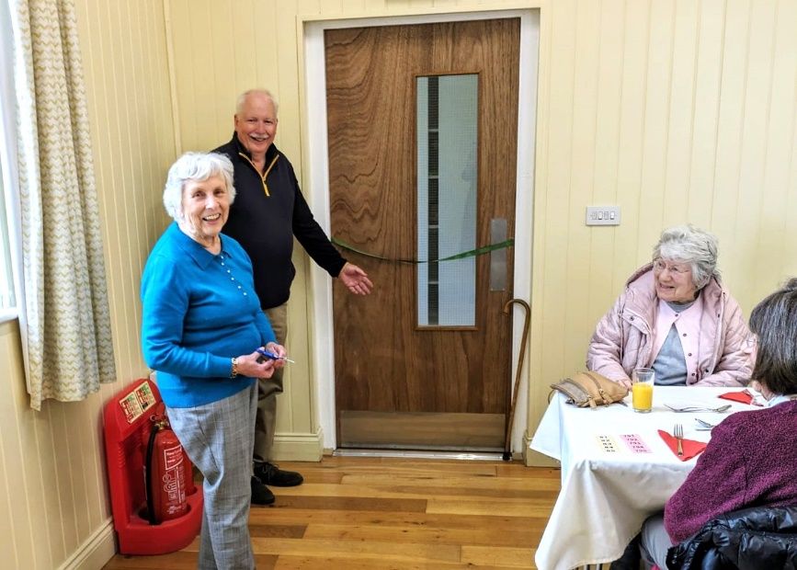
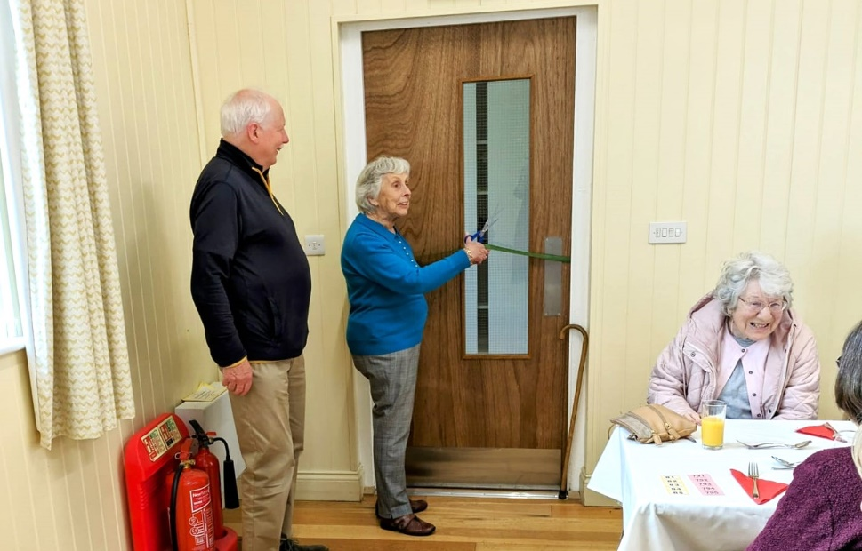
44 attended the lunch which went very well and was enjoyed by all.

